US Year 11 Edexcel – Pre-test
20 Questions | 60 minutes | Calculator allowed
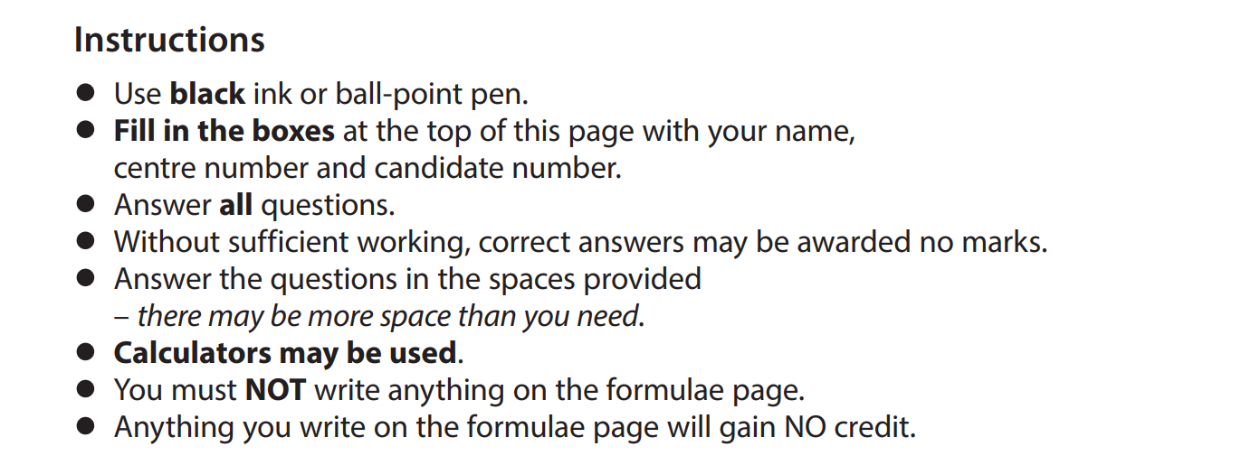

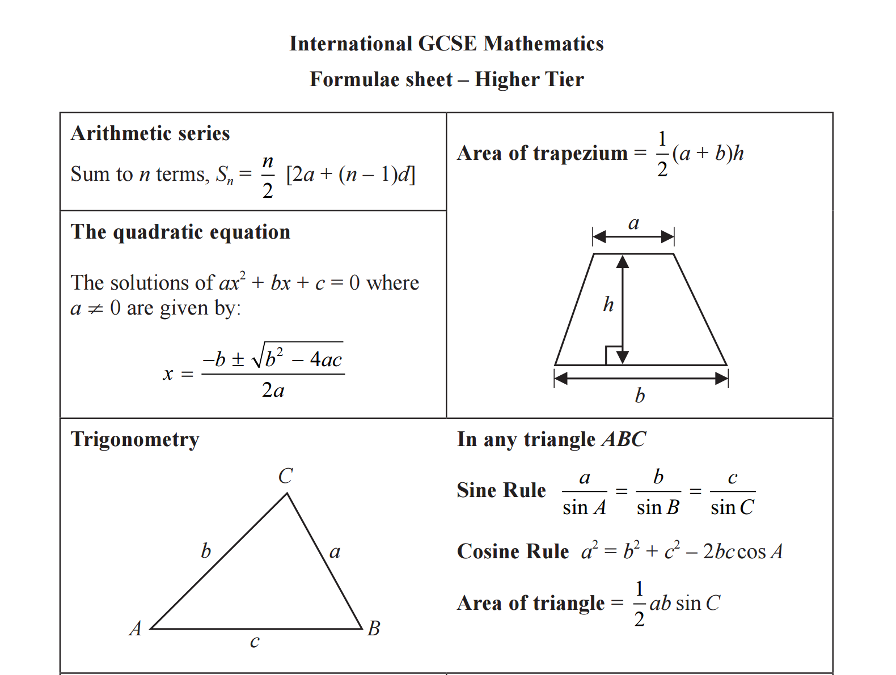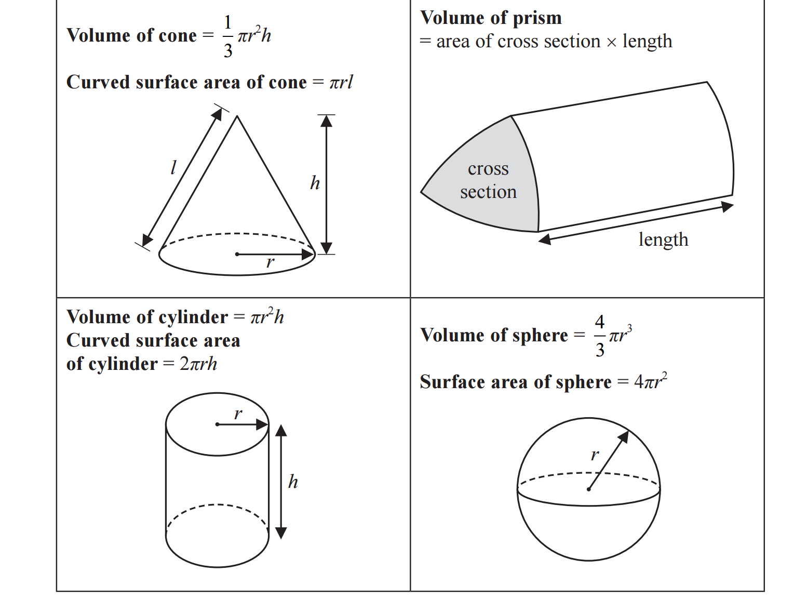
1. The length of a table is measured as 1.4 metres in length and 2.5 metres in width, correct to one decimal place.
- Write down the upper bound of the length of the table.

___________________________________

b) Write down the upper bound of the perimeter of the table.

___________________________________

2. Nisha invests 20 000 euros for 3 years in a savings account.
She gets 3.5% per year compound interest.
Work out how much money Nisha will have in her savings accountat the end of the 3 years.
Give your answer correct to the nearest euro.

___________________________________

3. Answer the following questions.
- Simplify $(p^{3})^{5}$

_________________________

- Expand and simplify $2n(4n+3)+n(n-4)$

_________________________
- Solve $\frac{2x+5}{3}=4-x$
Show clear algebraic working.

$x=$_________________________

4. Here is a Venn diagram.
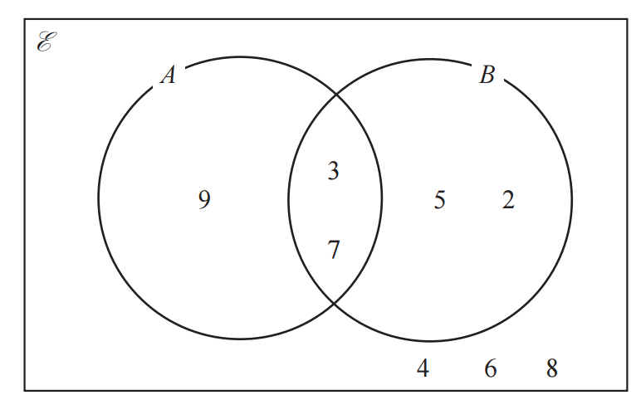
- List the members of the set $B$

_________________________
- List the members of the set $A∩B$

_________________________
- List the members of the set $A'$

_________________________

5. $ABCDE$ is a regular pentagon.
$DEFGHI$ is a regular hexagon.
$AF$ is a straight line.
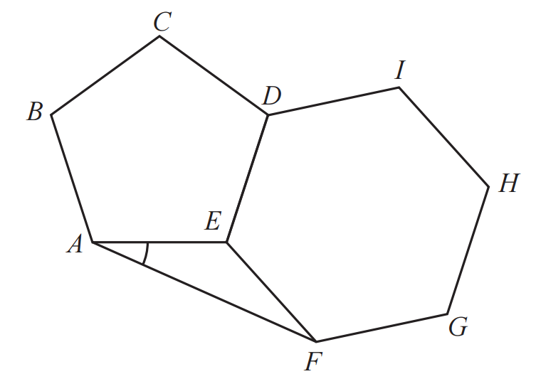

Work out the size of angle $EAF$

_________________________

6. $A=2^{3}×5^{4}×7×11$
$B=2^{2}×5^{2}×7^{2}$
$C=2^{2}×5^{3}×7^{4}$
Find the highest common factor (HCF) of A, B and C
Write your answer as a product of prime factors.

_________________________

7. Answer the following questions.
- Solve $x^{2}+5x-24=0$

_________________________

- Solve the inequality $3y+5>7y-10$

_________________________

- Solve $\frac{3x+2}{5}-\frac{2x+1}{3}=x$

$x=$_________________________
- Make $c$ the subject of the formula $f=\sqrt{\frac{a+bc}{c-d}}$

_________________________

8. Here are two similar triangles.
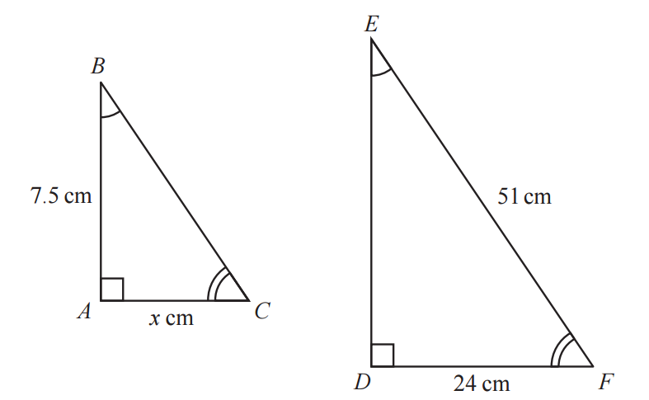
Work out the value of x
Show your working clearly.

$x=$_________________

9. $ABC$ is a right-angled triangle.
$D$ is a point on $BC$
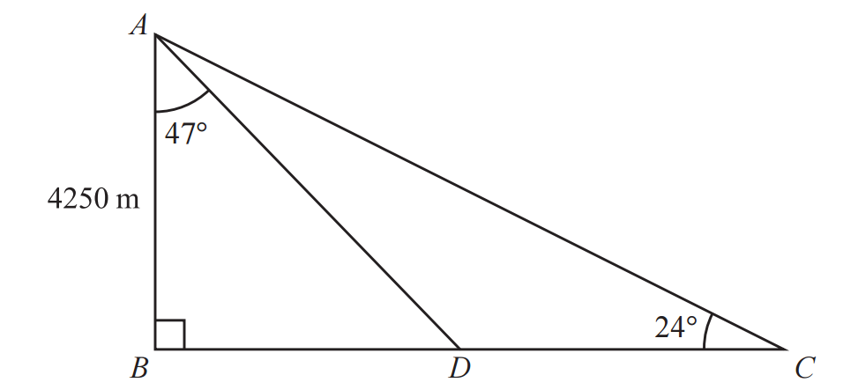
$AB=4250 m$
Angle $BAD=47$ degree
Angle $BCA=24$ degree
Work out the length of $DC$
Give your answer correct to the nearest integer.

_________________________$m$

10. The probability that Thomas gets to work early on Saturday is 0.7
If Thomas gets to work early on Saturday, the probability that he will get to work early on Sunday is 0.9
If Thomas does not get to work early on Saturday, the probability that he will get to work early on Sunday is 0.6

Work out the probability that Thomas gets to work early on both Saturday and Sunda

________________________________

11. $B$ is inversely proportional to the square of $d$
$B=0.25$when $d=12$
Find a formula for $B$ in terms of $d$

$B=$_________________________

12. Given that $\frac{3^{2n+3}}{3^{4}}=3^{3}×3^{1-2n}$
Find the value of $n$
Show your working clearly.

$n=$_________________________
13. On the grid below, draw the graph of $y=2(x+\frac{1}{2}x)$ for values of x from $0.5≤x≤6$
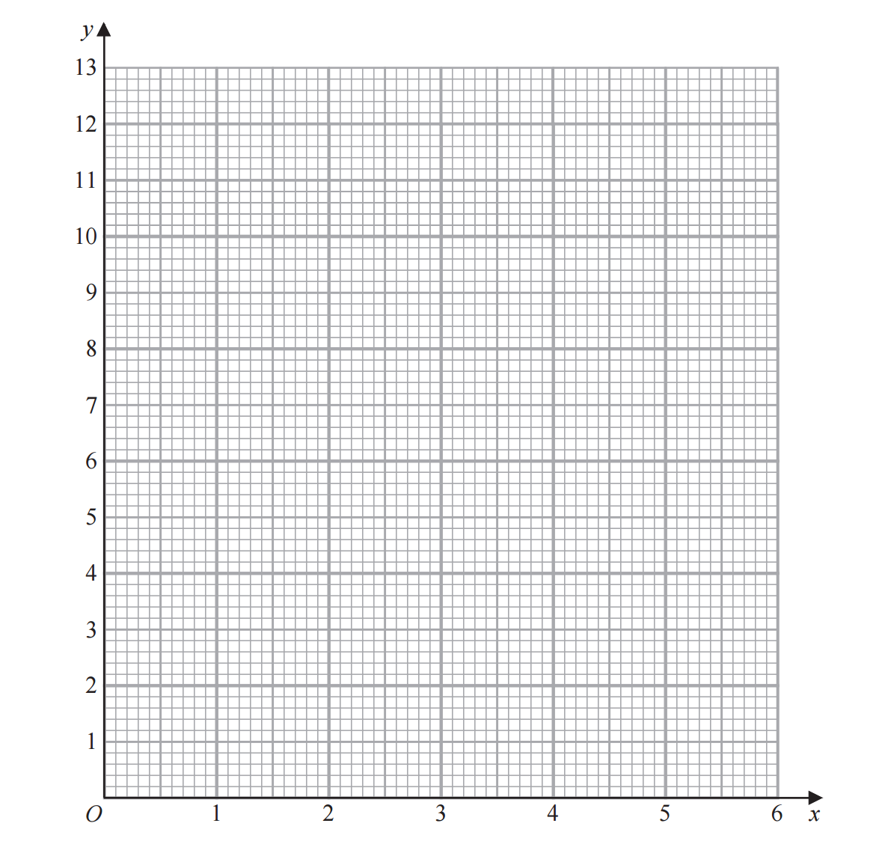

14. $OAPB$ is a sector of a circle, centre $O$
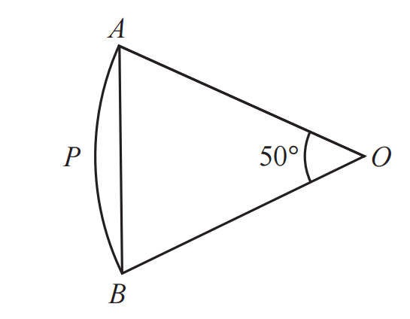
Angle $AOB=50$ degree
Area of triangle $OAB=120 cm^{2}$
Work out the area of the sector $OAPB$
Give your answer correct to 3 significant figures.

_________________________

15. Answer the following questions.

- Express $\sqrt{675}$ in the form $n\sqrt{27}$ where $n$ is a positive integer

_________________________________
- Show that $\frac{5-\sqrt{2}}{\sqrt{2}-1}$ can be written in the form $a+b\sqrt{2}$where $a$ and $b$ are integers.

_________________________________

16. The histogram shows information about the times some students took to complete a puzzle.

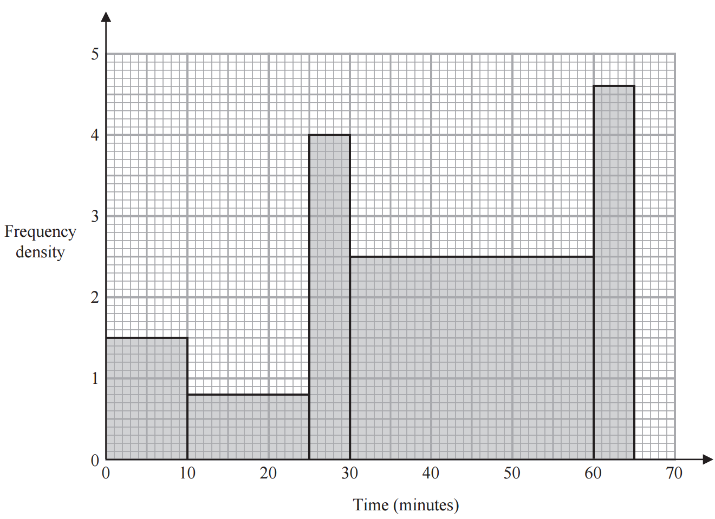
Work out an estimate for the fraction of these students who took between 20 minutes and 60 minutes to complete the puzzle.

_________________________

17. An arithmetic series has first term a and common difference d
The sum of the first 30 terms of the arithmetic series is 4395
The sum of the 10th term and the 20th term is 284
Work out the sum of the first 45 terms of the arithmetic series.
Show clear algebraic working.

_________________________

18. $A, B, C$ and $D$ are points on a circle, centre $O$
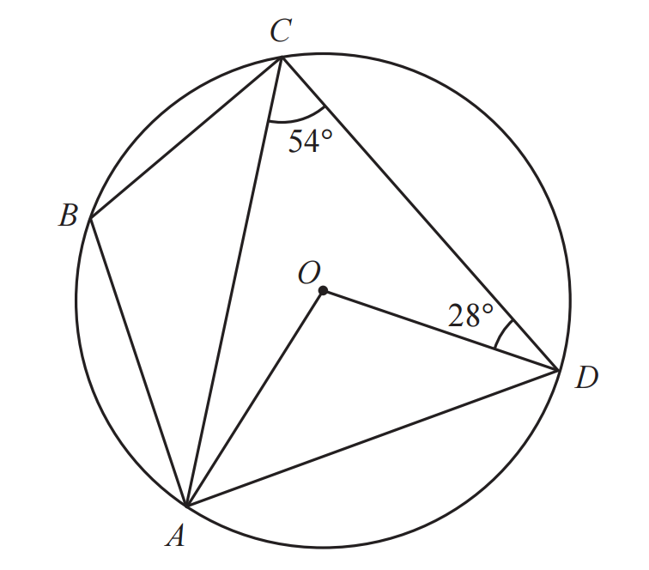
$AOD=$_________________________
$CAO=$_________________________
$ABC=$_________________________

19.The straight line $L$ is perpendicular to the straight line with equation $2x+y=9$
and passes through the point with coordinates (8, 11)
Find an equation for $L$
Give your answer in the form $y=mx+c$

_________________________

20. Solve the simultaneous equations
$x^{2}+y^{2}+y=3$
$x+2=y$
Show clear algebraic working.

(_____________,___________)

